Healthy Winship Free Lecture

June 14, 2016

Sugar and Cancer
A luncheon discussion with Winship expert

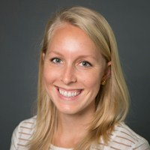
Emily Walters Klein, RD, CSO, LD
Registered Dietitian
Winship at Emory Saint Joseph’s Hospital

12:00 - 1:00 p.m.
Tuesday, June 14, 2016
Class Rooms 1 and 2, Ground Floor,
Winship at Emory Saint Joseph’s Hospital
5665 Peachtree Dunwoody Rd, Atlanta, GA 30342

