Healthy Winship Free Lecture

June 23, 2016

Back Health
A luncheon discussion with Emory expert

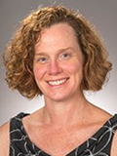
Ainsley Rossi, PT, DPT, OCS
Assistant Professor,
Division of Physical Therapy,
Emory University School of Medicine

12:00 - 1:00 p.m.
Thursday, June 23, 2016
John H. Kauffman Auditorium, (C5012, 5th Floor)
Winship Cancer Institute of Emory University (Bldg. C),
1365-C Clifton Road NE, Atlanta, Georgia 30322

