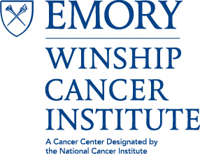
Research Seminar

“Modulation of microRNA Biogenesis in the DNA Damage Response and Ovarian Cancer.”
Xinna Zhang, PhD
Assistant Professor, Gynecologic Oncology and Reproductive Medicine
MD Anderson Cancer Network

Thursday, November 3, 2016
2:00PM-3:00PM
C3018, 3rd Floor Winship

