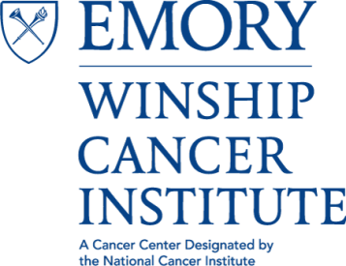

Winship Cancer Institute
LECTURE SERIES
Presented by
THE CANCER CELL BIOLOGY (CCB) PROGRAM

"Tackling Community Effects in Brain Tumors: Cooperation and Competition"

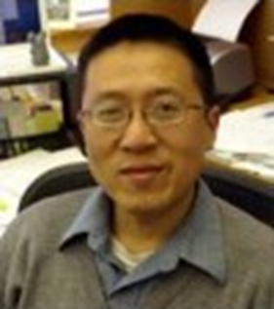
Hui Zong, PhD
Associate Professor, Microbiology, Immunology, and Cancer Biology
University of Virginia School of Medicine

Thursday, May 4, 2017 at 4PM
John H. Kauffman Auditorium
(C5012, 5th Floor Winship)
**Light refreshments provided**

Contact: Antonio Kyler akyler@emory.edu

