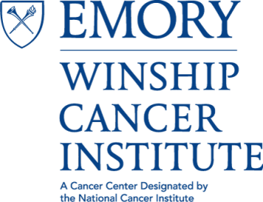

Cancer Genetics and Epigenetics (CGE)
Program Meeting

“Necessity of ZFHX3 for Progesterone Function in Mammary Gland Development and Tumorigenesis”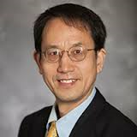
Jin-Tang Dong Ph.D.
Professor, Department of Hematology and Medical Oncology
Emory University School of Medicine
Co-Leader, Cancer Genetics and Epigenetics Research Program
Winship Cancer Institute of Emory University

Tuesday, May 2, 2017
4:00 PM – 5:00 PM
John H. Kauffman Auditorium
(C5012, 5th Floor Winship)
~Light Refreshments~

Contact: Antonio Kyler akyler@emory.edu

