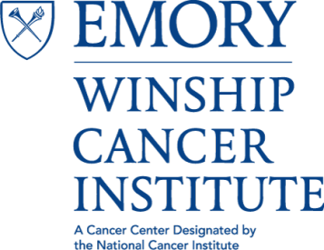

Cancer Genetics and Epigenetics (CGE)
Program Meeting

“Clinical Molecular Diagnostics for a Comprehensive Cancer Center: Moving forward with Pan-Heme and Pan-Solid Tumor panels”
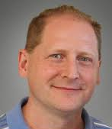
Michael Rossi Ph.D., FACMG
Assistant Professor, Division of Cancer Biology, Department of Radiation Oncology
Department of Pathology and Laboratory Medicine
Tuesday, June 6, 2017
4:00 PM – 5:00 PM
John H. Kauffman Auditorium
(C5012, 5th Floor Winship)
~Light Refreshments~

Contact: Antonio Kyler akyler@emory.edu

