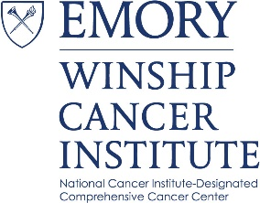
Cancer Genetics and Epigenetics (CGE)
Program Meeting

“Obesity and Breast Cancer: Opportunities and Challenges in Epigenetic Epidemiology”

Lauren E. McCullough, Ph.D. MSPH
Rollins Endowed Assistant Professor of Epidemiology
Rollins School of Public Health
Emory University

Tuesday, September 5, 2017
4:00 PM – 5:30 PM
John H. Kauffman Auditorium
(C5012, 5th Floor Winship)
~Light Refreshments~
Note: Before the lecture, a representative from Bionano Genomics will
give a 25min device presentation
Topic: “Beyond NGS: Bionano Genome Mapping Reveals
Structural Variation in Human Cancer and Genetic Disease”

Contact: Antonio Kyler akyler@emory.edu

