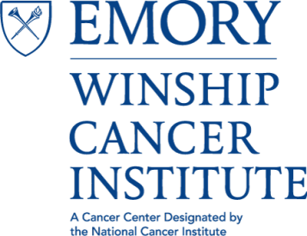

Winship Cancer Institute
LECTURE SERIES
Presented by
THE CANCER CELL BIOLOGY (CCB) PROGRAM

“Developing a Nanotechnology Tool for Serum Detection of Medulloblastoma Spread"
Hui Mao, PhD
Professor of Radiology and Biomedical Engineering
Head, Laboratory of Functional-Molecular Imaging & Nanomedicine
Co-Director, Molecular Imaging, Biomarkers and Probe Development
Emory University School of Medicine

Thursday, September 7, 2017 at 4PM
John H. Kauffman Auditorium
(C5012, 5th Floor Winship)
**Light refreshments provided**

Contact: Antonio Kyler akyler@emory.edu

