Please join your colleagues for a meeting of the:
Cancer Prevention & Control Program (CPC)
of the Winship Cancer Institute

Thursday, September 28, from 4:00 p.m. until 5:30 p.m.

Room CNR 2001 (2nd Floor, Room 2001) of the Claudia Nance Rollins School of Public Health Building

SEMINAR:
Methylation and telomere length in peripheral blood and lung cancer risk and survival
Jennifer Anne Doherty, MS, PhD

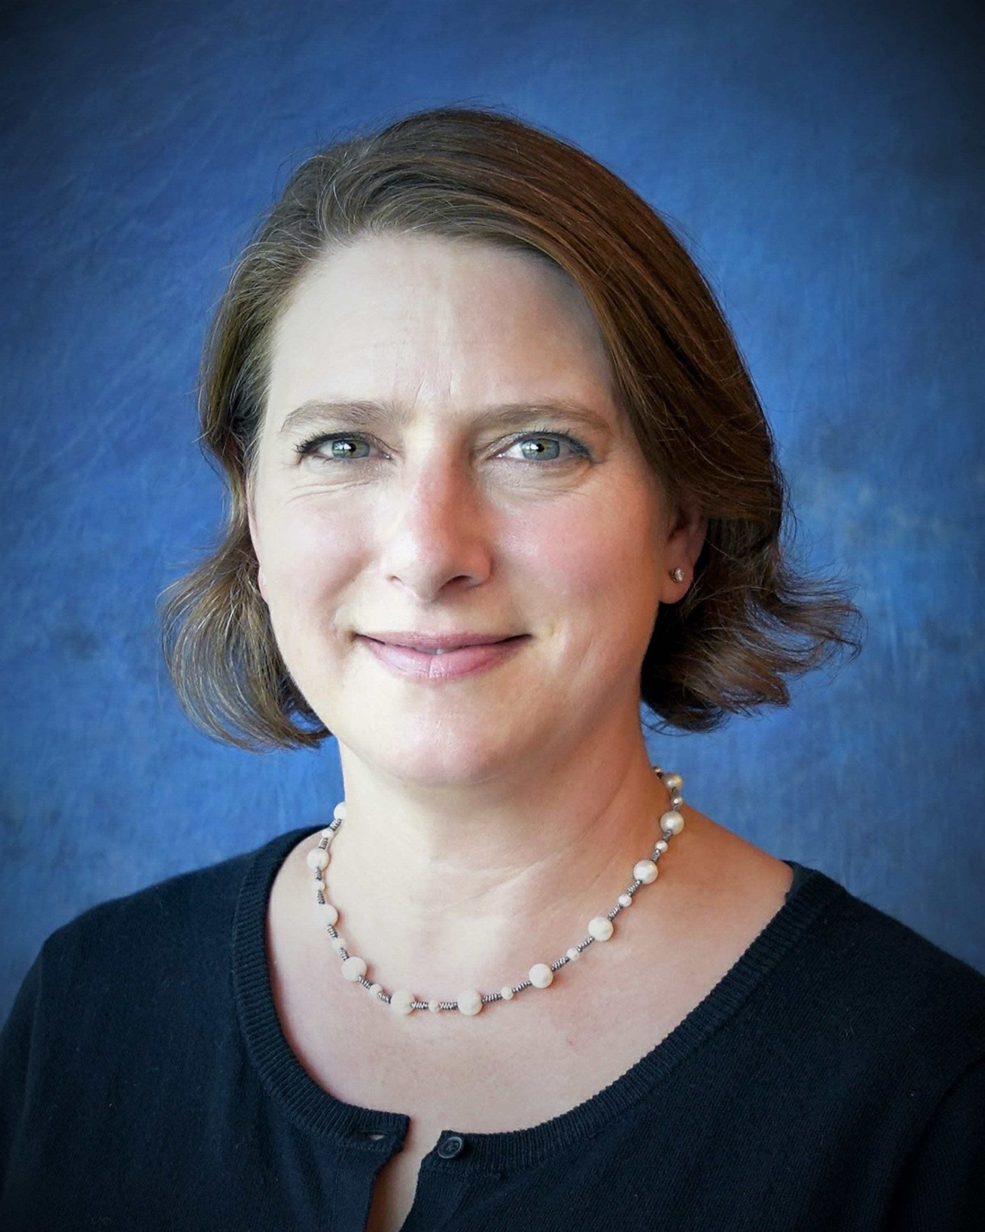

Please RSVP to
Dominique Claude Lavoisier (d.c.lavoisier@emory.edu).

Light refreshments will be served.

