***Cancer Genetics and Epigenetics (CGE)***

***Program Meeting***

**“Reprogramming Cell Fates in the Regulation**

**of Stem Cells and Cancer”**

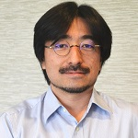

**Takahiro Ito, Ph.D.**

*Assistant Professor, Dept. of Biochemistry & Molecular Biology*

***University of Georgia***

**Tuesday, October 3, 2017**

**4:00 PM – 5:00 PM**John H. Kauffman Auditorium

**(C5012, 5th Floor Winship)**

*~Light Refreshments~*

Contact: Antonio Kyler [akyler@emory.edu](mailto:akyler@emory.edu)